Menu behavior:

* For Secondary page (Voting Environments, Voting Solutions from Hart,…):
  + Main menu text will turn red to indicate the active page
* The ‘in-page menu bar’ – text inside two red lines
  + When on a secondary or tertiary page, the text on the left is the secondary page title.

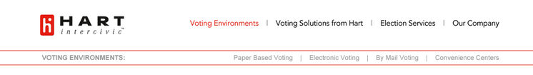

* The ‘in-page menu bar’ – text inside two red lines
  + When on a tertiary page, the page name will turn red to indicate active

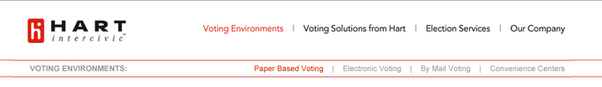

* When on a Product page the product name will be displayed on the left and the right will contain descriptive text (source not yet determined).

